PART P142036-R6-1-0  14X20X36 R6 PLNM EC/RAW  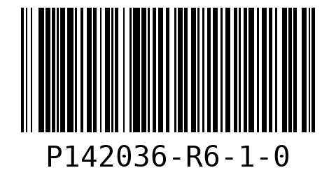  WO 01  LOT 08500  QTY 20 | PART P162036-R6-1-0  16X20X36 R6 PLENUM END CAP/RAW  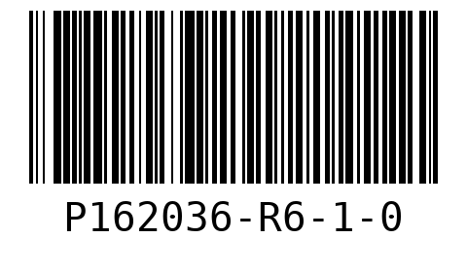  WO 02  LOT 08500  QTY 25
SHEET 1  PART P142036-R6-1-0  14X20X36 R6 PLNM EC/RAW  WO 01  LOT 08500 | SHEET 1  PART P162036-R6-1-0  16X20X36 R6 PLENUM END CAP/RAW  WO 02  LOT 08500 | SHEET 2  PART P142036-R6-1-0  14X20X36 R6 PLNM EC/RAW  WO 01  LOT 08500
SHEET 2
PART P162036-R6-1-0
16X20X36 R6 PLENUM END CAP/RAW
WO 02
LOT 08500

